**Student Name:** M**.**Nabeel Anwar , Syed Mohib Uddin

**Student ID:** 62553 ,62745

**Class ID:** 104498

Github Link: <https://github.com/syedMohib44/HCI-Project>

**Introduction:**

Electronic Commerce or e-commerce is business transactions that take place by communication networks. It is a process of buying and selling products, services, and information over the computer network. E-commerce is a set of dynamic technologies, applications and business process that link customers, suppliers, and communities through electronic transactions and the electronic exchange of information products and services. The idea of this project is to buy medicines without visiting the stores. I will design a user friendly interface by which customers can buy medicines like they buy from the pharmacy. This project can be used in any pharmaceutical shops. A person has to only order the desired medicines and in a very short time he will get them by a delivery boy at their doorstep.

**Goal of project:**

Many people choose to conduct shopping online because of the convenience. For example, when person shops at a brick-and-mortar store, he has to drive to the store, find a parking place, and walk throughout the store until he locates the products he needs. After finding the items he wants to purchase, he may often need to stand in long lines at the cash register. Say 'goodbye' to the days when you stood in line waiting, and waiting, and waiting some more for a store clerk to finally check out your items. Online shopping transactions occur instantly-saving your time. The aim of this system is to help and enable customers shop medicines online.

**Working:**

The idea of this project is to create and develop an online system by which customers will purchase medicines without having any difficulty of visiting the store. This methodology is reflected in the design of an online store to save quality time of an individual. The purpose of this project is to create interactive design prototype for online store application it will not be functional but the GUI will be interactive.

**Doctor Appointment System:**

We are also making a UI for the doctor appointment system which will help to override the problems prevailing in the practicing manual system. This will reduce the hardships faced by the existing system. No formal knowledge will be needed for the user to use the system. User will be able to see the doctor’s list, doctor schedule details, doctor fee and will also be able to book an appointment. It will also track the information of all the appointments. The user friendly UI will provide ease for the patients to easily book an appointment by searching a particular doctor name too.

* **Use Case diagram:**

<<Include>>

**Shopkeeperss**

**<<Include>>**

**Customer/patient**

**<<include>>**

**Receptionist**

**Doctor**

* **Task Analysis:**

**Goal :**

1.Place order(customer)

2. conform order and manage medicines (shopkeper)

3.get appointment(patient)

4. conform appointment(receptionist)

5. find the nearest hospital (patient)

6. find the schedule of Dr

7.approve appointment(Dr)

**Precondition:**

Application ,mobile, account , id ,password, registered hospital and store

**Subtask:**

* Registration (patient ,customer , Dr ,Receptionist)
* Login (All)
* To place the order need to select the medicine from the list
* Add to cart with quantity
* Add update and delete the item in order list
* Cancel the order if order is place and you don’t want this order
* Also send the medical report to the shopkeeper to get the medicine
* After place the order generate recipt
* Pay bill after get the order (goal 1 complete)
* Shopkeeper can add update delete the item into the list
* See the medicine list
* Get the medicine list to the customer and conform the order
* Conform the order
* Recommind the doctor to the patient or customer
* See the sealing detail
* Also cancel the order
* Accept the order and send the delivery to the customer (goal 2 complete)
* Patient find the nearest hospital through man
* Patient can check the doctor timing and days
* Patient fill the form
* Patient submit the reports
* Patient also get appointment
* Also cancel the appointment (gaol3,5 complete)
* Receptionist watch the appointment list
* Receptionist set the appointment
* Receptionist sent the report to the doctor
* Receptionist add update delete the dr schedule (goal 4 complete)
* Dr can add update change there days and timing
* Dr get the patient repot through receptionist
* Dr cancel the appointment
* Dr also approve appointment
* Dr check the appointment list (goal 7 comple
* **Story Board:**

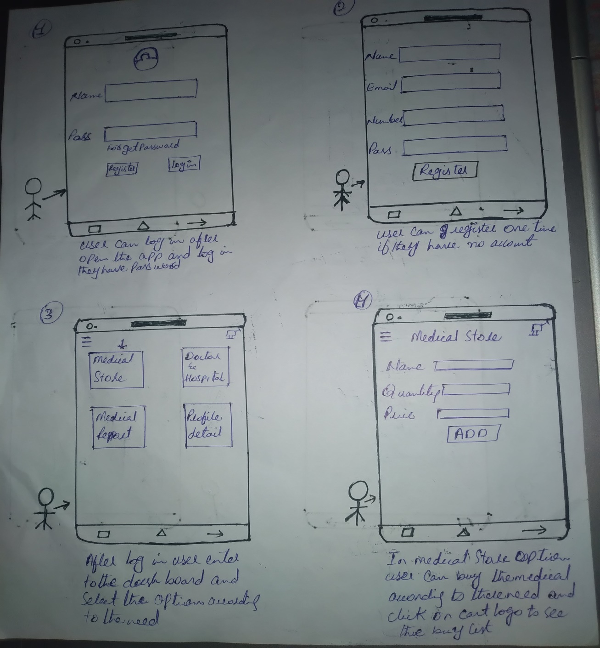

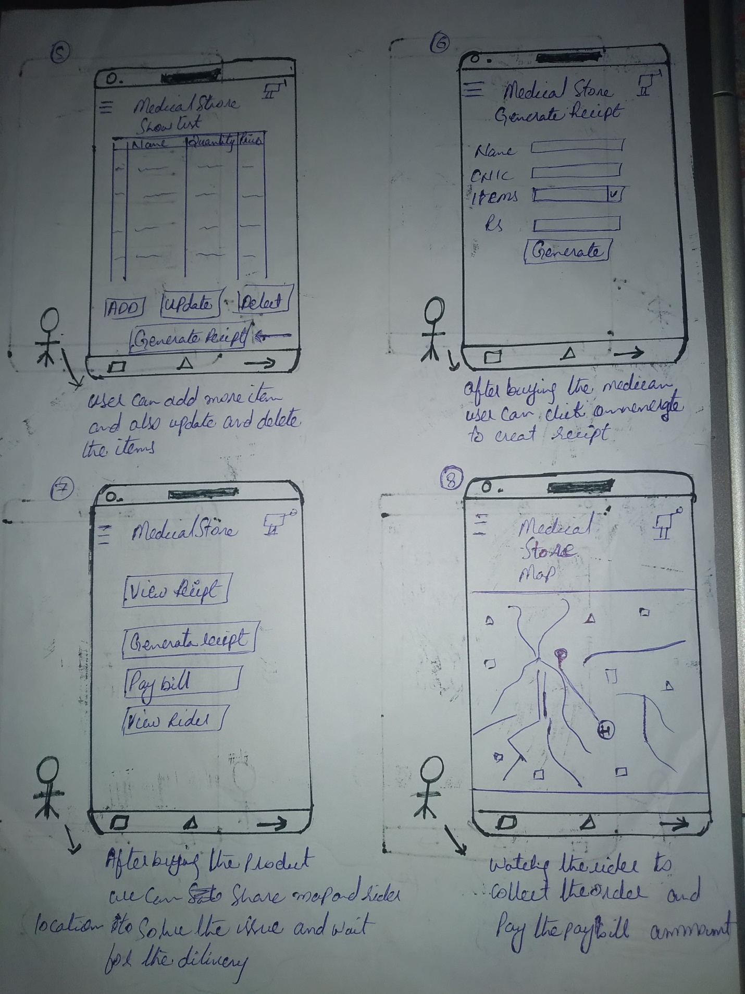

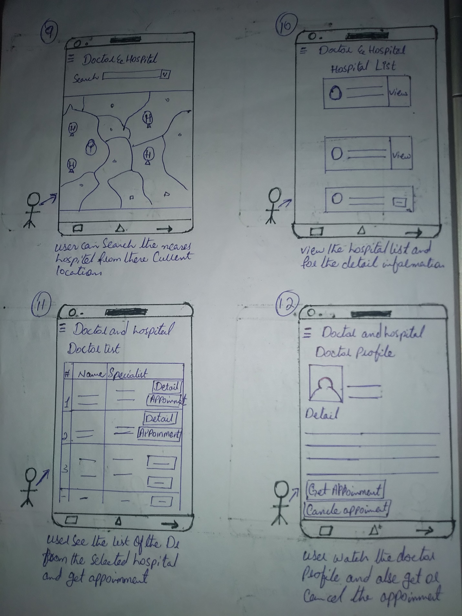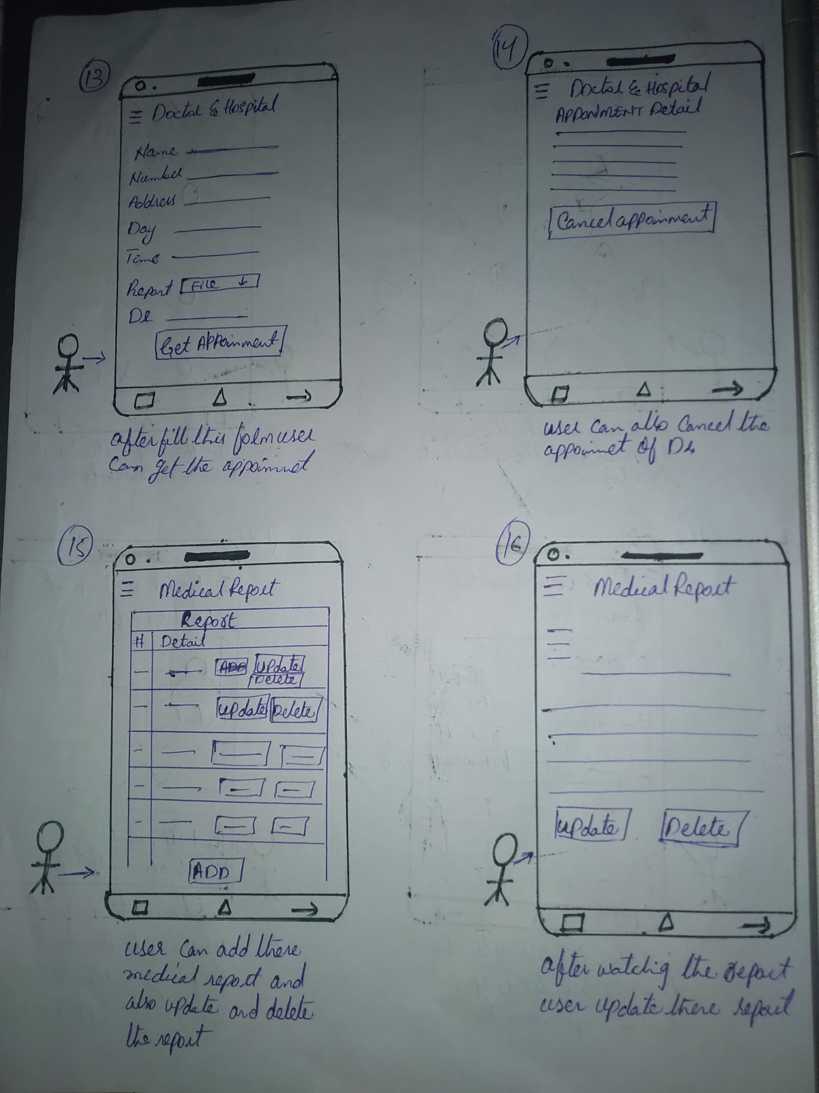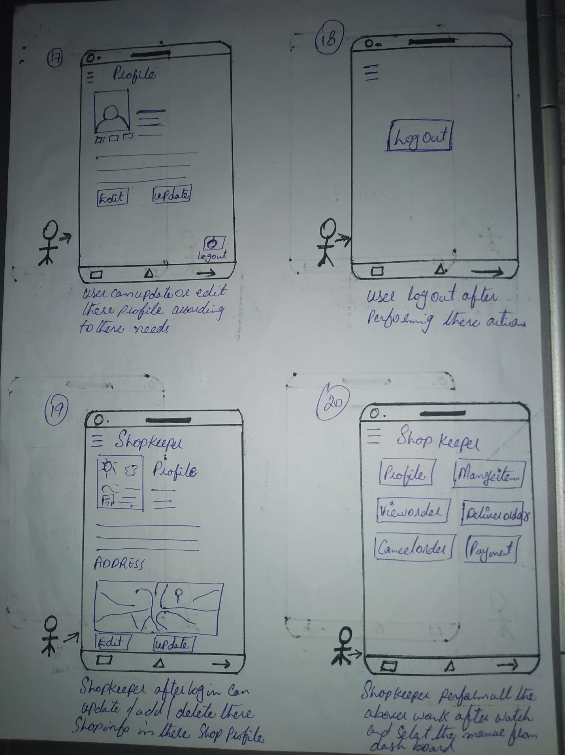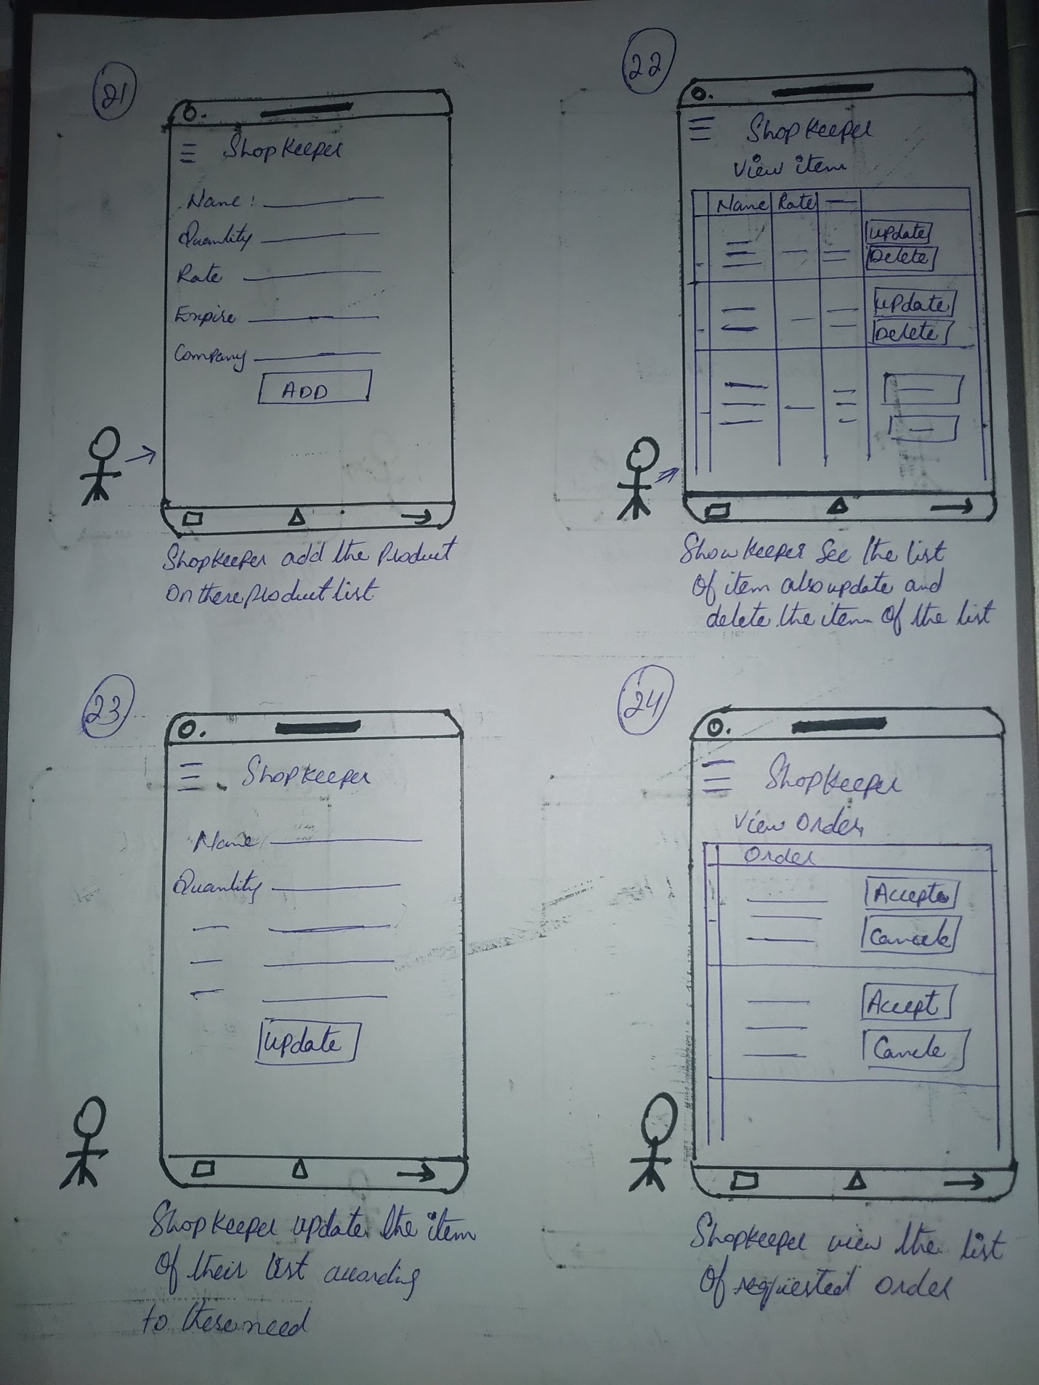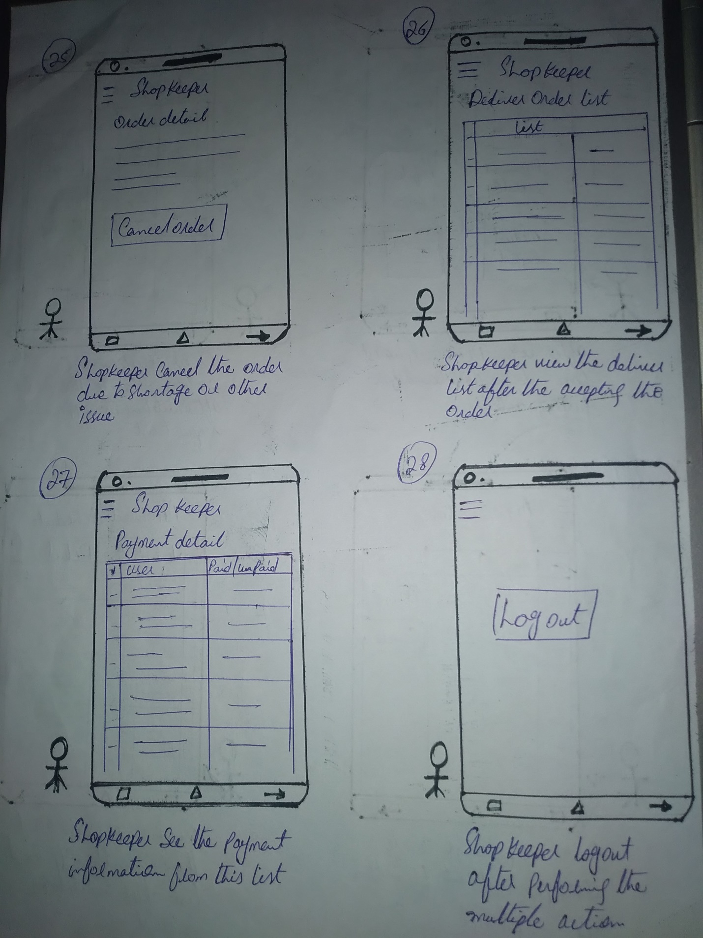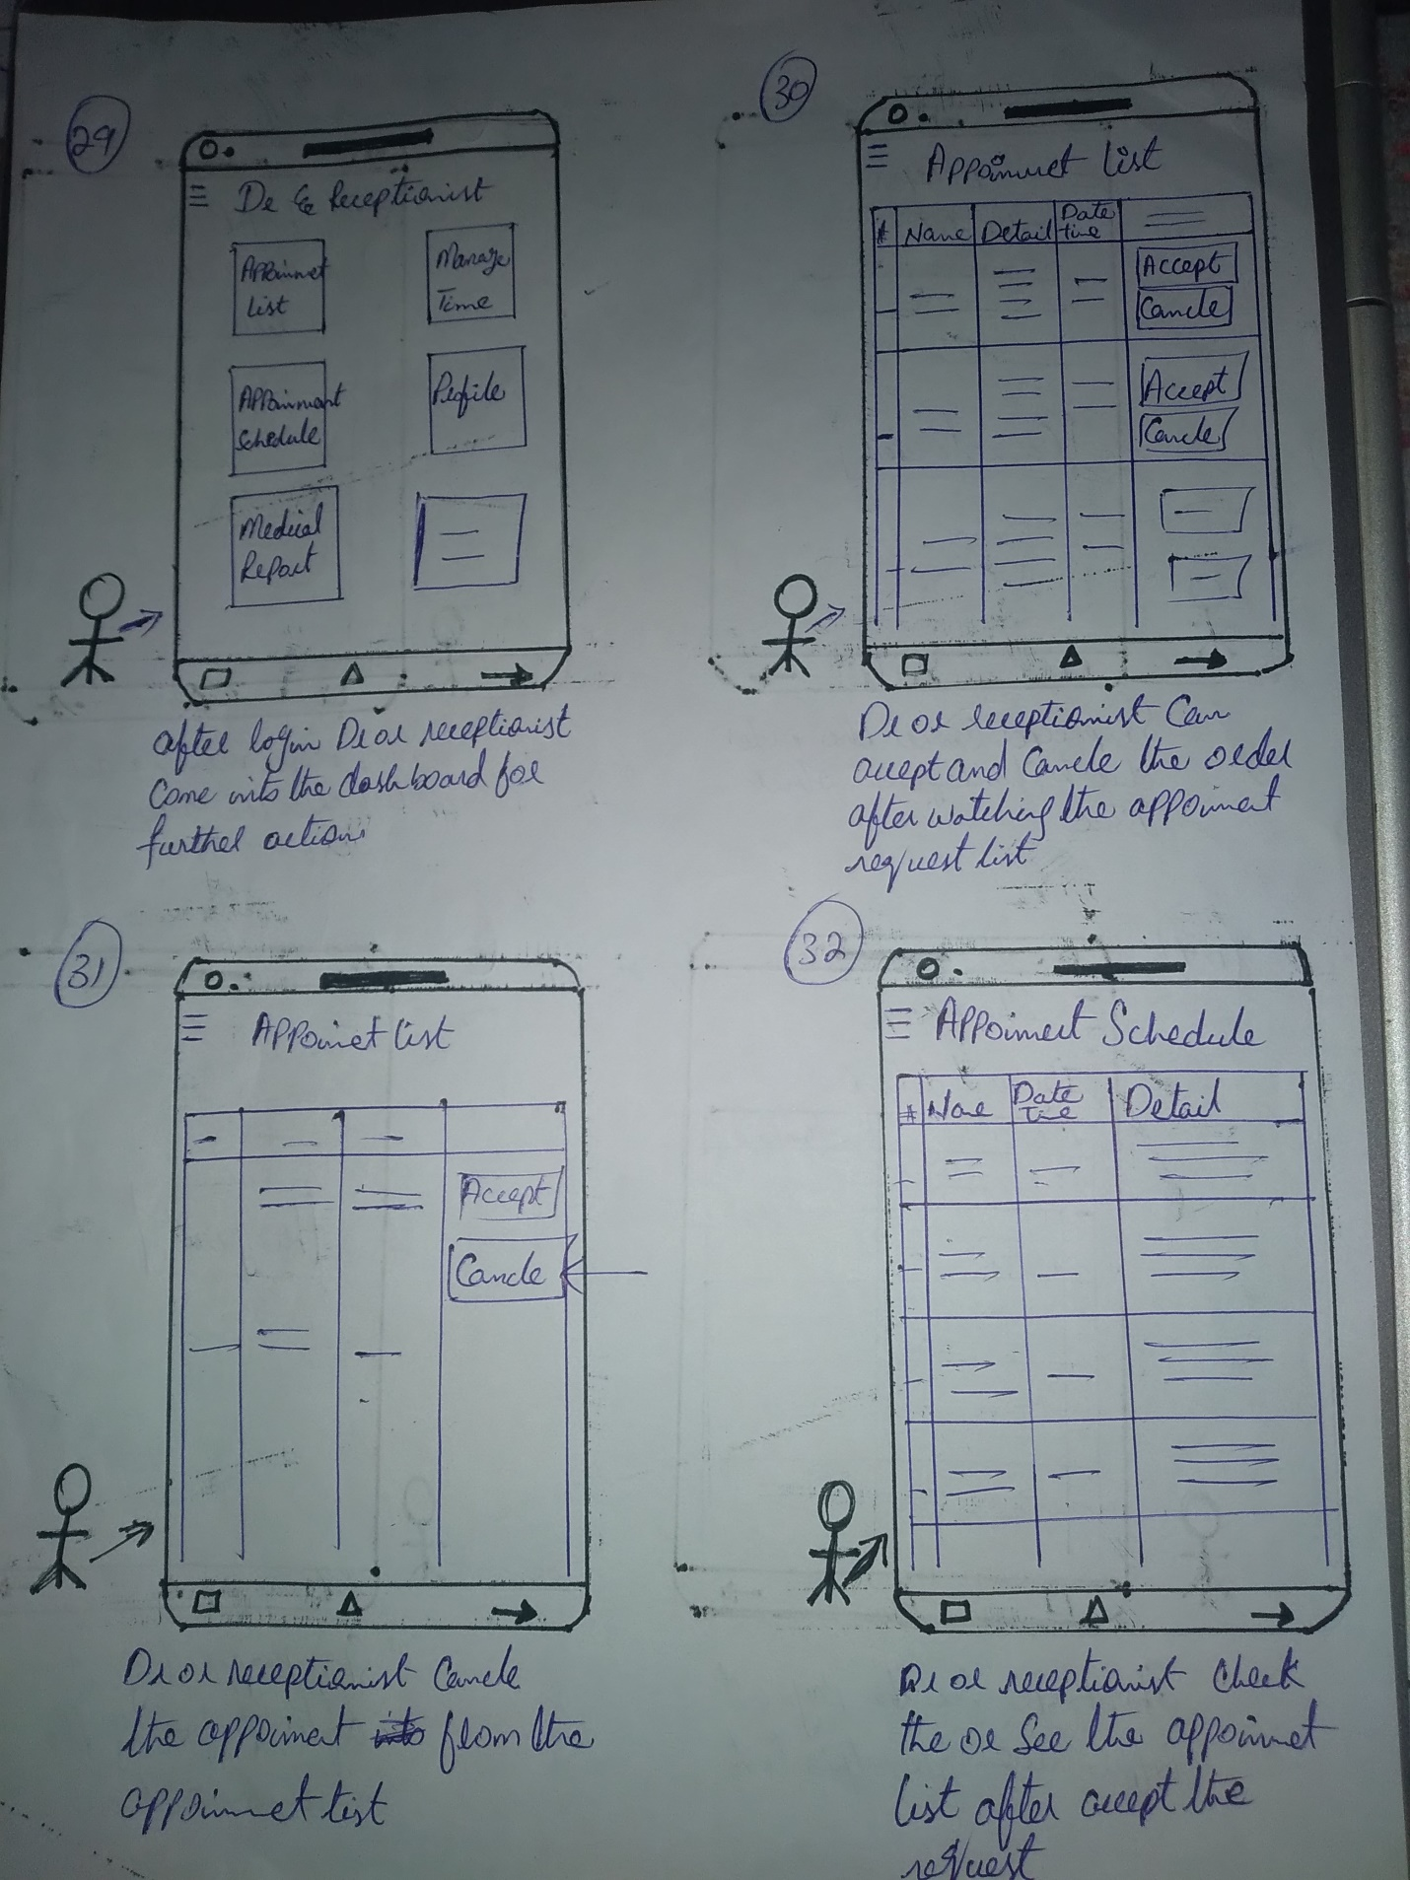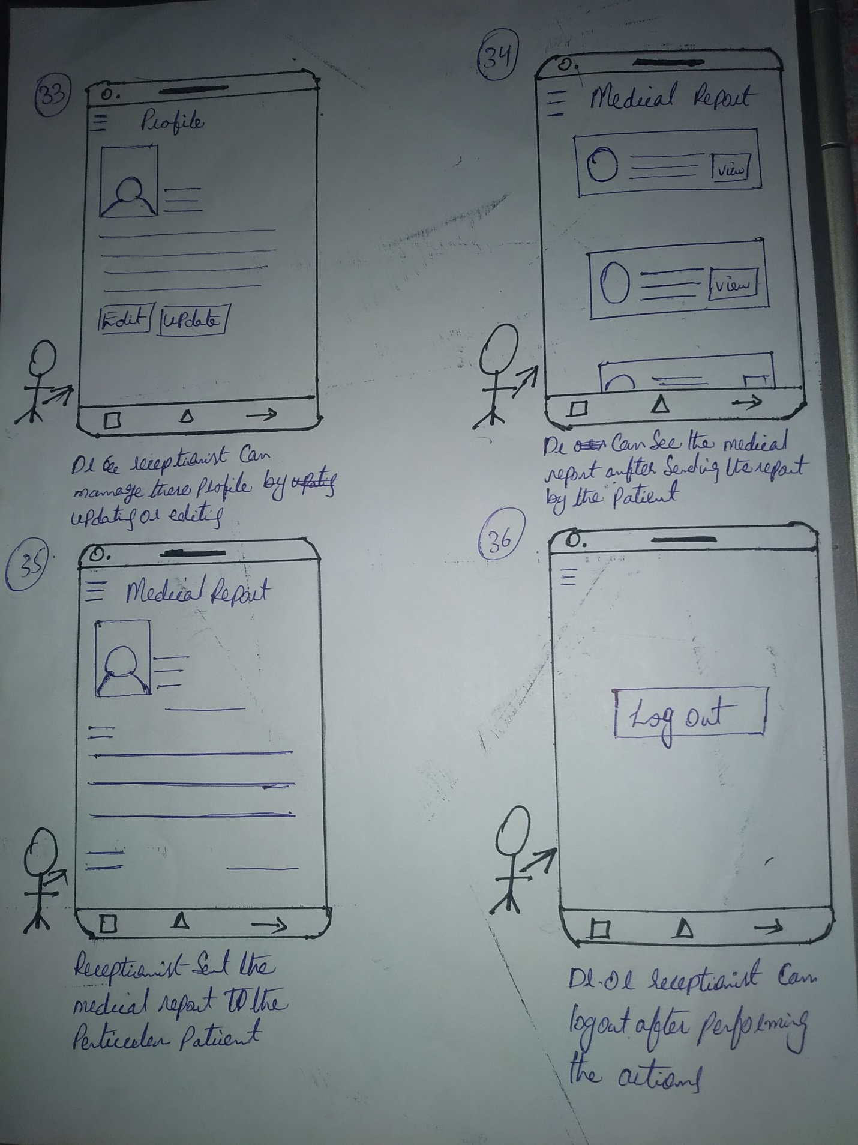

* **ProtoType:**

**On github**

**Link** <https://github.com/syedMohib44/HCI-Project>